REAL-TIME COMMUNICATION WEB APPLICATION
A project report submitted to
Sri Ramakrishna Mission Vidyalaya College of Arts and Science, Coimbatore- 20 in partial fulfillment of the requirements for the award of the degree of

BACHELOR OF COMPUTER APPLICATIONS
Project Report Submitted by

S G. LINGESAN

( 23UCA020 )

Under the guidance of
Dr. M. JAIKUMAR MCA., M.Phil., Ph.D., M.Sc.(Psy).,
Associate Professor & Head, Department of Computer Applications


DEPARTMENT OF COMPUTER APPLICATIONS
SRI RAMAKRISHNA MISSION VIDYALAYA COLLEGE OF ARTS AND SCIENCE,
(An Autonomous Institution Affiliated to Bharathiar University, Re-Accredited by NAAC with ‘A+’ Grade)
COIMBATORE - 641 020

MARCH - 2026

CERTIFICATE

This is to certify that the project entitled “REAL-TIME COMMUNICATION WEB APPLICATION’’ submitted to Sri Ramakrishna Mission Vidyalaya College of Arts and Science, Coimbatore-20, Affiliated to Bharathiar University, in partial fulfillment of the requirements for the award of the degree of BACHELOR OF COMPUTER APPLICATIONS is a record of original project work done by LINGESAN S G ( 23UCA020 ) during the Academic year 2025-2026 of his study in the Department of Computer Applications at Sri Ramakrishna Mission Vidyalaya College of Arts and Science, Cbe-20, under my supervision and guidance and the dissertation has not formed the basis for the award of any Degree / Diploma / Associateship / Fellowship or other similar title to any candidate of any university.

Date:

Place: Coimbatore-20 Signature of the Guide

Countersigned

Head of the Department Principal

Internal Examiner External Examiner

i

DECLARATION

I hereby declare that the thesis entitled “REAL-TIME COMMUNICATION WEB APPLICATION” submitted in partial fulfillment of the requirements for the award of the degree of BACHELOR OF COMPUTER APPLICATIONS of Bharathiar University is a record of original work done by me during the Academic Year 2025-2026 under the supervision and guidance Dr. M. JAIKUMAR MCA., M.Phil., Ph.D., M.Sc.(Psy)., Associate Professor & Head, Department of Computer Applications, Sri Ramakrishna Mission Vidyalaya College of Arts and Science, Cbe-20. The dissertation has not formed the basis for the award of any Degree / Diploma / Associateship / Fellowship or other similar title to any candidate of any university.

Date: Signature of the Candidate

Place: Coimbatore. S G. LINGESAN
(23UCA020)

ii

ACKNOWLEDGEMENT
I would like to express my sincere thanks to our Secretary, Dr . K. KANDAPPAN M.A., M.PHIL., LL.L., DCHIL., PH.D., Sri Ramakrishna Mission Vidyalaya College of Arts and Science, Cbe - 20 for giving me the permission to do the project

At the outset I record my profound thanks to our Principal Dr. A. MUTHUSAMY M.Sc., M.Ed., M.Phil., Ph.D., Sri Ramakrishna Mission Vidyalaya College of Arts and Science, Cbe-20 for following me to carry out this project work, I take this opportunity to acknowledge my deep sense of gratitude to our honorable Director Dr. R. SRIDHAR M.Sc., MCA, M.Phil., Ph.D., Sri Ramakrishna Mission Vidyalaya College of Arts and Science Coimbatore – 20 for permitting me to carry my project work.
I would like to express my heartfelt gratitude to Dr. M. JAIKUMAR MCA., M.Phil., Ph.D., M.Sc.(Psy)., Associate Professor & Head, Department of Computer Applications, Sri Ramakrishna Mission Vidyalaya College of Arts and Science Coimbatore – 20 for following me to carry out this project work.
I wish to express my sincere heartfelt thanks to Dr. M. JAIKUMAR MCA, M.Phil., Ph.D., M.Sc.(Psy)., Associate Professor & Head, Department of Computer Applications, Sri Ramakrishna Mission Vidyalaya College of Arts and Science, Cbe-20 for his kind help, generous support, valuable advice and suggestion for the successful completion of the study.
I would also express my sincere thanks to Dr. J.M. DHAYASHANKAR MCA., M.Phil.,Ph.D., SET., NET., Associate Professor, Dr .D. GOVINDARAJ M.Sc., M.Phil., Ph.D., Assistant Professor, Sri. M. RAJKUMAR MCA.,(Ph.D)., Assistant Professor, Sri P.YUVARAJ M.Sc., M.Phil., (Ph.D.), Assistant Professor and all the faculty members of Computer Applications Department, Sri Ramakrishna Mission Vidyalaya College of Arts and Science, Coimbatore - 20 for their valuable support and suggestions in my project work.
Finally, I express my heartful gratitude to my beloved Parents and Friends without whose sustained support, I could not have made debut in Computer Applications.

iii

SYNOPSIS

This project is a REAL-TIME CHAT WEB APPLICATION that allows users to communicate with each other through messages. Users can create an account, log in, search for other users, and start chatting individually or in groups. The application supports real-time messaging, so messages are delivered instantly. It also includes features like profile management, group chat creation, and notifications for new messages.
The application is developed using the MERN stack, which includes React.js for the frontend, Node.js and Express.js for the backend, and MongoDB for the database. The system is designed to be simple, fast, and user-friendly. This project helps in understanding full-stack development and real-time communication in web applications.

Iv

CONTENTS
CERTIFICATE i
PROJECT LETTER ii
DECLARATION iii
ACKNOWLEDGEMENT iv
SYNOPSIS v

CHAPTER NO TITLE PAGE NO

1 INTRODUCTION 1
1.1 Overview of the Project 1
1.2 Need for the System 2
1.3 Objectives of the Project 3
1.4 Scope of the Project 4

2 SYSTEM STUDY 5
2.1 Existing System 6
2.2 Proposed System 6
2.3 Advantages of Proposed System 7

3 SYSTEM DESIGN 8
3.1 Architecture Diagram 8
3.2 Data Flow Diagram (DFD) 9
3.3 ER Diagram 11
3.4 Database Design / Tables 13

4 SYSTEM IMPLEMENTATION 15
4.1 Frontend (React.js) 15
4.2 Backend (Node.js & Express.js) 17
4.3 Database (MongoDB) 19
4.4 API Integration 20
4.5 Real-Time Communication (Socket.io) 20

5 SYSTEM TESTING 24
5.1 Testing Objectives 25
5.2 Unit Testing 25
5.3 Testing Objectives
5.4 Input & Output Testing 27

6 RESULTS AND DISCUSSION 28

7 CONCLUSION AND FUTURE SCOPE 30

8 32
8.1 Reference Books 32
8.2 Reference Websites 33

9 APPENDIX 34
9.1 Screenshots 34
9.2 Source Code 40

1. INTRODUCTION

1.1 Overview of the Project
The Real-Time Chat Application is a web-based communication system that allows users to send and receive messages instantly. The application provides features such as user registration and login, individual chat, group chat, and real-time messaging. Users can search for other users, start conversations, and create group chats to communicate with multiple users at the same time. The system also includes profile management where users can update their personal details and upload a profile picture.
This application is developed using the MERN stack, which includes React.js for the frontend, Node.js and Express.js for the backend, and MongoDB for the database. Socket.io is used to enable real-time communication between users. The system is designed to be simple, user-friendly, and responsive, making it accessible on both desktop and mobile devices. This project demonstrates the practical implementation of full-stack development and real-time communication in modern web applications.

1.2 Need for the System
In today’s digital world, communication plays an important role in both personal and professional life. Traditional communication methods are often slow and less efficient, especially when instant interaction is required. There is a need for a system that allows users to communicate quickly, easily, and in real time without any delay. Many existing systems are either complex, not user-friendly, or lack important features like group communication and real-time updates.
This project is developed to overcome these limitations by providing a simple and efficient real-time chat application. It allows users to send messages instantly, create group chats, and manage their profiles in one platform. The system ensures fast communication, better user experience, and accessibility from anywhere. It also helps in understanding modern web technologies and real-time communication, making it useful for both practical usage and learning purposes.

1.3 Objectives of the Project
The main objective of this project is to develop a real-time chat application that enables users to communicate easily and instantly through the internet. The system aims to provide a simple and user-friendly interface where users can register, log in, search for other users, and start individual or group conversations. It focuses on delivering messages in real time without delay using modern web technologies.
Another objective of this project is to implement important features such as group chat creation, user profile management, and notification for new messages. The system also aims to ensure smooth performance, secure authentication, and proper data storage using the MERN stack. Overall, the project helps in understanding full-stack development and real-time communication in web applications while providing a practical solution for modern communication needs.
1.4 Scope of the Project
The scope of this project is to develop a real-time chat application that enables users to communicate through individual and group messaging. The system allows users to create accounts, log in securely, search for other users, and start conversations instantly. It also supports group chat creation, profile management, and real-time message exchange, making communication fast and efficient. The application is designed to be responsive and accessible on different devices such as desktops and mobile phones.
In addition, the project focuses on implementing modern web technologies like the MERN stack and Socket.io for real-time communication. The system can be further extended in the future by adding advanced features such as voice and video calling, message encryption, file sharing improvements, and push notifications. Therefore, this project provides a strong foundation for building more advanced communication systems.

2. SYSTEM STUDY
2.1 Existing System
In the present scenario, communication is carried out using various traditional and modern methods such as telephone calls, emails, and basic messaging applications. While these systems are widely used, they have several limitations when it comes to real-time and efficient communication. Phone calls require both users to be available at the same time, which is not always possible. Emails, on the other hand, are mainly used for formal communication and are not suitable for instant interaction, as responses may be delayed.
Many basic messaging systems provide limited functionality and do not support real-time message delivery effectively. In some cases, users may experience delays in receiving messages, which affects smooth communication. Additionally, these systems may not provide features such as group chat, user search, profile management, and real-time notifications. Some applications also have complicated user interfaces, making them difficult for users to understand and use efficiently.
Another major drawback of existing systems is the lack of integration of modern web technologies. Some applications require installation on specific devices and may not be accessible across multiple platforms like mobile and desktop. This reduces flexibility and convenience for users. Moreover, certain systems do not ensure proper data management and security, which can lead to issues related to user privacy and data handling.
Because of these limitations, existing systems are not always suitable for fast, reliable, and user-friendly communication. There is a need for a system that provides real-time messaging, easy accessibility, better user experience, and advanced features such as group communication, notifications, and profile management. This project aims to overcome these limitations by developing an efficient and modern communication platform.

2.2 Proposed System
The proposed system is a Real-Time Chat Application designed to provide fast, reliable, and user-friendly communication between users. This system overcomes the limitations of existing communication methods by enabling instant message delivery using real-time technology. Users can register, log in securely, search for other users, and start individual conversations easily. In addition, the system allows users to create group chats where multiple users can communicate simultaneously, making it suitable for both personal and professional use.
The application is developed using the MERN stack, which includes React.js for the frontend, Node.js and Express.js for the backend, and MongoDB for data storage. Socket.io is used to implement real-time communication, ensuring that messages are delivered instantly without delay. The system also includes important features such as user profile management, profile picture upload, and notifications for new messages. These features improve user interaction and provide a better communication experience.
Unlike existing systems, the proposed system is designed to be simple, efficient, and accessible across different devices such as desktops and mobile phones. It provides a clean and easy-to-use interface, making it suitable for all types of users. The system also ensures proper data handling and secure authentication, which helps in protecting user information. Overall, the proposed system offers a complete and modern solution for real-time communication with improved performance, usability, and scalability.
2.3 Advantages of Proposed System
The proposed system provides an efficient and modern solution for real-time communication by overcoming the limitations of existing systems. It is designed to offer fast, reliable, and user-friendly interaction between users. By using advanced technologies like the MERN stack and Socket.io, the system ensures instant message delivery and smooth performance. The application supports both individual and group communication, making it suitable for various purposes such as personal chatting, teamwork, and collaboration. It also provides a simple interface, allowing users to easily understand and use the system without any difficulty.

In addition to this, the system includes several important features that improve usability and user experience. It ensures secure authentication, proper data management, and accessibility across multiple devices. The application is scalable, meaning it can be enhanced with more features in the future. Overall, the proposed system provides a complete communication platform that is efficient, flexible, and easy to use.
Advantages of the Proposed System
- Provides real-time messaging with instant delivery
- Supports both individual and group chat
- Easy-to-use and user-friendly interface
- Allows user search and quick conversation start
- Includes profile management and profile photo upload
- Provides notifications for new messages
- Works on multiple devices (desktop and mobile)
- Ensures secure authentication and data handling
- Built using modern technologies (MERN stack & Socket.io)
- Can be extended with additional features in the future

3. SYSTEM DESIGN
3.1 Architecture Diagram
The architecture of the Real-Time Chat Application follows a three-tier structure consisting of the frontend, backend, and database. This structure helps in organizing the system efficiently and ensures smooth communication between different components. The frontend is developed using React.js, which provides a user-friendly interface for users to interact with the system. Users can perform actions such as login, signup, searching users, sending messages, and creating group chats through the frontend.
The backend is developed using Node.js and Express.js, which handle all the server-side operations. It manages user authentication, chat creation, message handling, and communication with the database. Socket.io is integrated into the backend to enable real-time communication between users. It ensures that messages are sent and received instantly without refreshing the page. The backend acts as a bridge between the frontend and the database, processing requests and sending appropriate responses.
The database used in this system is MongoDB, which stores all the application data such as user details, chat information, and messages. It provides a flexible and efficient way to manage data. When a user sends a message, the frontend sends a request to the backend, which processes the request, stores the message in the database, and uses Socket.io to deliver the message to the receiver in real time. This continuous interaction between frontend, backend, and database forms the overall architecture of the system.
Components of Architecture
- Frontend (React.js): Handles user interface and user interaction
- Backend (Node.js & Express.js): Processes requests and manages logic
- Database (MongoDB): Stores user, chat, and message data
- Socket.io: Enables real-time message communication

┌──────────────────────┐
│ Frontend │
│ (React.js) │
│ Login / Chat UI │
└─────────┬────────────┘
│ API Request
↓
┌──────────────────────┐
│ Backend │
│ Node.js + Express │
│ Auth / Chat Logic │
└─────────┬────────────┘
│
┌───────────┴───────────┐
↓ ↓
┌───────────────┐ ┌────────────────┐
│ MongoDB │ │ Socket.io │
│ (Database) │ │ Real-Time Chat │
│ Users/Chats │ │ Messaging │
└───────────────┘ └────────────────┘

3.2 Data Flow Diagram (DFD)
The Data Flow Diagram (DFD) represents how data moves within the Real-Time Chat Application. It shows the flow of information between users, the system, and the database. The DFD helps in understanding how user inputs are processed and how the system responds to those inputs.
In this system, users interact with the application by performing actions such as registration, login, searching users, sending messages, and creating group chats. These requests are sent from the frontend to the backend server. The backend processes the requests, interacts with the database to store or retrieve data, and sends the response back to the user. For real-time messaging, Socket.io is used to instantly deliver messages between users.
The DFD mainly consists of three components: External Entity (User), Process (System/Server), and Data Store (Database). The user provides input to the system, the system processes it, and the data is stored or retrieved from the database accordingly.

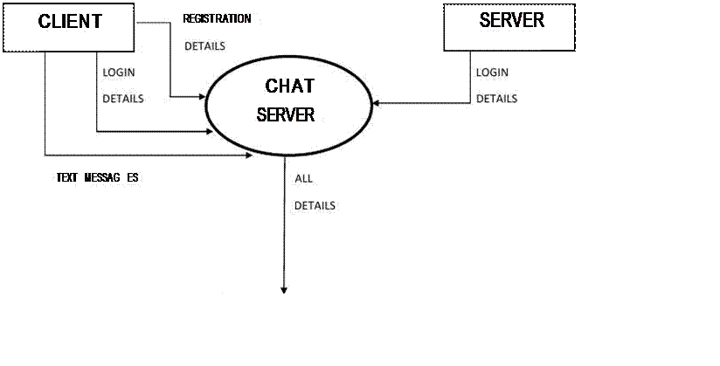
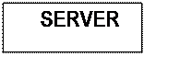
Context level DFD (zero level)

Explanation Points (for writing)
- User sends request (login, message, search)
- System processes the request
- Data is stored/retrieved from database
- Messages are delivered in real time using Socket.io

3.3 ER Diagram
The Entity-Relationship (ER) Diagram represents the structure of the database used in the Real-Time Chat Application. It shows the relationship between different entities such as User, Chat, and Message. The ER diagram helps in understanding how data is organized and how different components of the system are connected with each other.
In this system, the main entity is the User, who can register, log in, and communicate with other users. A user can participate in multiple chats, and each chat can have one or more users. Chats can be either individual or group chats. Another important entity is Message, which stores all the messages sent by users. Each message is linked to a specific chat and has a sender. The relationships between these entities ensure proper data storage and retrieval in the application.
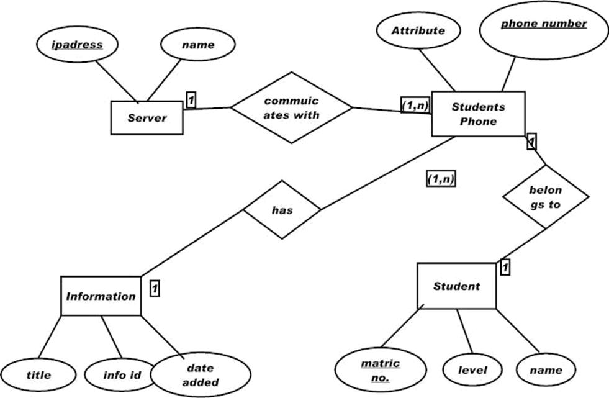
ER Diagram

3.4 Database Tables (MongoDB Schema Explanation)
The Real-Time Chat Application uses MongoDB as its database, which stores data in the form of collections and documents. Unlike traditional relational databases, MongoDB is a NoSQL database that stores data in JSON-like format. This makes it flexible and suitable for handling dynamic data such as users, chats, and messages.
In this system, there are three main collections: User, Chat, and Message. Each collection stores specific information required for the application. The User collection stores user details such as name, email, password, and profile picture. The Chat collection stores information about individual and group chats, including chat name, users involved, and group admin. The Message collection stores all messages sent between users, including sender, content, chat reference, and timestamp.
These collections are interconnected using references (ObjectId), which helps in linking data between collections. For example, the Message collection references both the User and Chat collections to identify who sent the message and in which chat it was sent. This structure ensures efficient data storage and retrieval.
Collections and Fields
1. User Collection
Stores user information.
{
_id: ObjectId,
name: String,
email: String,
password: String,
profilePic: String,
online: Boolean,
createdAt: Date
}
2. Chat Collection
Stores chat details (individual & group).
{
_id: ObjectId,
chatName: String,
isGroupChat: Boolean,
users: [ObjectId], // references User
groupAdmin: ObjectId,
createdAt: Date
}
3. Message Collection
Stores messages.
{
_id: ObjectId,
sender: ObjectId, // references User
content: String,
chat: ObjectId, // references Chat
file: String,
createdAt: Date
}

4. Database Diagram
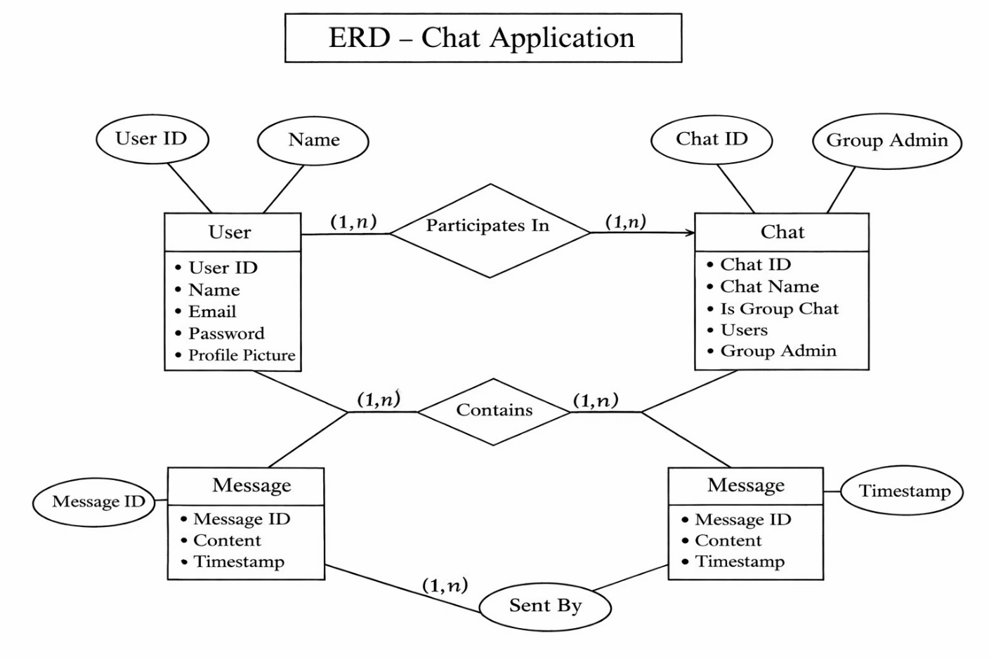

4. SYSTEM IMPLEMENTATION
4.1 Frontend (React.js)
The frontend of the Real-Time Chat Application is developed using React.js, which is a popular JavaScript library used for building interactive user interfaces. It is responsible for handling all user interactions and displaying data in a user-friendly manner. The frontend provides different pages such as Login, Signup, Dashboard, Chat Interface, and Profile page. These pages allow users to perform actions like registering, logging in, searching users, sending messages, and managing their profiles.
React.js uses a component-based architecture, which helps in organizing the code into reusable components. This improves code readability and makes the application easier to maintain. React Router is used for navigation between different pages without refreshing the browser. The frontend communicates with the backend through API calls using Axios, and it also connects with Socket.io for real-time message updates.
The user interface is designed using CSS to ensure a clean and responsive layout that works on both desktop and mobile devices. The frontend plays an important role in providing a smooth and efficient user experience.
Features of Frontend
- Developed using React.js for dynamic user interface
- Uses React Router for page navigation
- Implements component-based architecture
- Provides pages like:
- Login Page
- Signup Page
- Dashboard
- Chat Page
- Profile Page
- Allows user search and chat selection
- Displays real-time messages using Socket.io
- Uses Axios for API communication
- Responsive design using CSS styling
- Provides user-friendly interface and smooth experience
4.2 Backend (Node.js & Express.js)
The backend of the Real-Time Chat Application is developed using Node.js and Express.js, which handle all the server-side operations and business logic of the system. The backend is responsible for processing user requests, managing authentication, handling chat creation, storing messages, and communicating with the database. It acts as a bridge between the frontend and the database, ensuring that data flows correctly and securely.
Express.js is used to create RESTful APIs for different functionalities such as user registration, login, chat management, message handling, and user search. The backend also integrates Socket.io to enable real-time communication, allowing messages to be sent and received instantly without refreshing the page. Additionally, middleware is used for authentication and request validation to ensure secure access to the system.
The backend is designed to be efficient, scalable, and secure. It handles multiple user requests simultaneously and ensures proper data management using MongoDB. Overall, the backend plays a crucial role in maintaining the functionality and performance of the application.
Features of Backend
- Developed using Node.js for server-side execution
- Uses Express.js for building RESTful APIs
- Handles user authentication (login & signup)
- Manages chat creation (individual & group chat)
- Processes and stores messages in database
- Implements Socket.io for real-time communication
- Uses middleware for authentication and security
- Connects with MongoDB database
- Handles API requests and responses efficiently
- Ensures secure and scalable system architecture
4.3 Database (MongoDB)
The database used in this Real-Time Chat Application is MongoDB, which is a NoSQL database designed to store data in a flexible and scalable manner. Unlike traditional relational databases, MongoDB stores data in the form of collections and documents using JSON-like format. This makes it suitable for handling dynamic data such as user information, chat details, and messages in real-time applications.
In this system, MongoDB is used to store and manage all the application data efficiently. The main collections include User, Chat, and Message. The User collection stores details such as name, email, password, and profile picture. The Chat collection stores information about individual and group chats, including users and group admin. The Message collection stores messages along with sender information, chat reference, and timestamps. These collections are connected using ObjectId references, which help in linking related data across collections.
MongoDB provides high performance, easy scalability, and flexible schema design, making it ideal for modern web applications. It ensures quick data retrieval and efficient storage, which is essential for real-time communication systems.

Features of Database (MongoDB)
- Uses NoSQL database structure
- Stores data in collections and documents
- Uses JSON-like format (BSON)
- Handles dynamic and flexible data structure
- Stores data in collections such as:
- User
- Chat
- Message
- Uses ObjectId references to connect collections
- Provides fast data retrieval and storage
- Supports scalability for large data
- Suitable for real-time applications
- Ensures efficient data management
4.4 API Integration
API Integration is an important part of the Real-Time Chat Application, as it enables communication between the frontend and backend. APIs (Application Programming Interfaces) are used to send and receive data between the client (React.js) and the server (Node.js & Express.js). The frontend makes HTTP requests to the backend APIs to perform various operations such as user registration, login, searching users, creating chats, and sending messages.
In this application, RESTful APIs are developed using Express.js, and the frontend interacts with these APIs using Axios. Each API endpoint is responsible for a specific function, such as authentication, chat management, and message handling. When a user performs an action, the frontend sends a request to the corresponding API, the backend processes it, interacts with the database if required, and returns a response to the frontend.
API integration ensures smooth data flow, proper communication between system components, and efficient handling of user requests. It plays a crucial role in maintaining the functionality and performance of the application.

Features of API Integration
- Uses RESTful APIs for communication
- Connects frontend (React.js) with backend (Node.js)
- Uses Axios for sending HTTP requests
- Handles operations such as:
- User registration and login
- User search
- Chat creation (individual & group)
- Message sending and retrieval
- Ensures smooth data transfer between client and server
- Provides structured request and response handling
- Supports secure communication using authentication
- Improves application performance and scalability
4.5 Real-Time Communication (Socket.io)
Real-time communication is a key feature of this chat application, which allows users to send and receive messages instantly without refreshing the page. This functionality is implemented using Socket.io, a JavaScript library that enables real-time, bidirectional communication between the client and the server. It establishes a persistent connection, allowing data to be transmitted immediately whenever an event occurs.
In this system, when a user sends a message, the frontend emits an event using Socket.io. The backend receives this event and broadcasts the message to the intended user or chat room. This ensures that messages are delivered instantly to all participants in a chat. Socket.io also supports features like joining chat rooms, handling multiple users, and maintaining active connections. It plays a crucial role in providing a smooth and interactive chatting experience.
Overall, Socket.io enhances the performance of the application by enabling instant communication, reducing delays, and improving user experience. It makes the application more dynamic and responsive, similar to modern messaging platforms.

Features of Real-Time Communication (Socket.io)
- Enables instant message delivery
- Provides bidirectional communication between client and server
- Uses event-based communication system
- Supports chat rooms for group messaging
- Handles multiple users simultaneously
- Eliminates the need for page refresh
- Ensures fast and efficient communication
- Improves user experience and responsiveness
- Works seamlessly with Node.js backend
- Ideal for real-time applications like chat systems
5. SYSTEM TESTING
5.1 Testing Objectives
System testing is an important phase in software development that ensures the application works correctly and meets the required specifications. The main objective of testing in this project is to identify and fix errors, verify system functionality, and ensure that all features work as expected. Testing helps in improving the quality, reliability, and performance of the application before it is deployed for users.
In this Real-Time Chat Application, testing is performed on different modules such as user authentication, chat functionality, group chat, message sending, and real-time communication. The system is tested to ensure that users can register, log in, search for other users, send messages, and receive messages without any issues. Special attention is given to real-time messaging using Socket.io to ensure that messages are delivered instantly and correctly.
Testing also ensures that the application is user-friendly, secure, and responsive across different devices. By performing proper testing, the system can provide a smooth and error-free user experience.

Objectives of System Testing
- To verify that all system features work correctly
- To identify and fix bugs or errors
- To ensure proper user authentication (login & signup)
- To test chat functionality (individual and group chat)
- To check real-time message delivery using Socket.io
- To ensure data is stored and retrieved correctly
- To test user interface for usability and responsiveness
- To ensure secure handling of user data
- To improve system performance and reliability
- To provide a smooth and error-free user experience
5.2 Unit Testing
Unit testing is the process of testing individual components or modules of the application separately to ensure that each part works correctly. In this project, unit testing is performed on small units such as functions, API endpoints, and components in both frontend and backend. The main purpose of unit testing is to identify errors at an early stage and ensure that each module performs its intended function properly.
In the Real-Time Chat Application, different modules such as user authentication, chat creation, message sending, and API responses are tested individually. For example, the login function is tested to verify whether valid users can log in successfully, and the message API is tested to ensure messages are stored correctly in the database. By testing each unit separately, it becomes easier to detect and fix issues without affecting the entire system.
Unit testing improves the reliability and quality of the application by ensuring that all individual parts function correctly before integrating them into the complete system.
Features of Unit Testing
- Tests individual components or modules separately
- Helps in early detection of errors
- Ensures each function works as expected
- Improves code quality and reliability
- Makes debugging easier and faster

Examples in This Project
- Testing user registration and login functions
- Testing API endpoints (GET, POST, PUT requests)
- Testing chat creation functionality
- Testing message sending and storage
- Testing frontend components like forms and inputs

5.3 Integration Testing
Integration testing is the process of testing how different modules of the system work together as a complete system. After unit testing individual components, integration testing ensures that all parts of the application interact properly without errors. It verifies the data flow between frontend, backend, and database, and checks whether combined functionalities work as expected.
In this Real-Time Chat Application, integration testing is performed to ensure smooth communication between the React frontend, Node.js backend, and MongoDB database. For example, when a user sends a message, the frontend sends a request to the backend, the backend processes the request and stores the message in the database, and the message is then delivered in real time using Socket.io. All these steps are tested together to ensure the system functions correctly as a whole.
Integration testing also helps in identifying issues related to data communication, API responses, and real-time message delivery. It ensures that all modules are properly connected and work together efficiently, providing a seamless user experience.
Features of Integration Testing
- Tests interaction between different modules
- Ensures data flow between frontend, backend, and database
- Verifies API communication and responses
- Checks real-time messaging functionality
- Identifies errors in module integration
- Improves overall system performance and reliability

Features of Integration Testing
- Tests interaction between different modules
- Ensures data flow between frontend, backend, and database
- Verifies API communication and responses
- Checks real-time messaging functionality
- Identifies errors in module integration
- Improves overall system performance and reliability

5.4 Input & Output Testing
Input and Output Testing is performed to ensure that the system correctly accepts user inputs and produces the expected outputs. This type of testing verifies whether the data entered by the user is valid, properly processed, and results in accurate responses from the system. It helps in identifying errors related to data entry, validation, and system responses.
In this Real-Time Chat Application, input testing is done on various user inputs such as registration details, login credentials, search fields, and message inputs. The system checks whether the entered data is valid, such as proper email format, required fields, and correct password input. Output testing ensures that the system displays correct results, such as successful login messages, chat lists, user search results, and real-time messages. It also verifies that error messages are shown when invalid data is entered.
This testing ensures that the application handles both valid and invalid inputs correctly and provides appropriate outputs, improving the overall user experience and system reliability.
Features of Input Testing
- Checks valid and invalid user inputs
- Ensures required fields are filled correctly
- Validates email format and password fields
- Prevents incorrect or empty data submission
- Improves data accuracy and system reliability

Features of Output Testing
- Verifies correct display of data to users
- Ensures accurate chat and message display
- Checks real-time message updates
- Displays error messages for invalid inputs
- Confirms successful operations (login, signup, message send)
Features of Output Testing
- Verifies correct display of data to users
- Ensures accurate chat and message display
- Checks real-time message updates
- Displays error messages for invalid inputs
- Confirms successful operations (login, signup, message send

6. RESULTS AND DISCUSSION
The Real-Time Chat Application was successfully developed and tested using modern web technologies such as React.js, Node.js, Express.js, MongoDB, and Socket.io. The system is able to perform all the required functionalities efficiently, including user registration, login, individual chat, group chat, and real-time messaging. The application provides a smooth and user-friendly interface, allowing users to communicate easily without any delay.
During testing, all modules of the system were verified and found to be working correctly. Messages are delivered instantly using Socket.io, and the data is stored and retrieved properly from the MongoDB database. The system also handles user inputs effectively and displays appropriate outputs, including success and error messages. The application is responsive and works well on both desktop and mobile devices.
The discussion of results shows that the system meets the project objectives and provides an efficient communication platform. The integration of frontend, backend, and database is successful, and the real-time functionality enhances user experience. Overall, the project demonstrates the effective implementation of a full-stack web application with real-time features.

Results of the System
- Successful user registration and login
- Proper user search and chat creation
- Smooth individual and group chat functionality
- Instant real-time message delivery using Socket.io
- Correct data storage and retrieval from MongoDB
- Responsive design for desktop and mobile devices
Discussion
- The system provides fast and efficient communication
- Real-time messaging improves user interaction
- Integration of technologies ensures smooth performance
- User-friendly interface enhances usability
- The application is scalable and can be improved further

7. Conclusion and Future Scope
Conclusion
The Real-Time Chat Application has been successfully developed using the MERN stack and Socket.io for real-time communication. The system provides essential features such as user authentication, individual chat, group chat, and instant message delivery. It ensures smooth communication between users with a simple and user-friendly interface. All modules of the application have been tested and found to work efficiently, providing accurate results and reliable performance.
The project demonstrates the practical implementation of full-stack web development and real-time communication technologies. It fulfills the objectives of creating a fast, secure, and efficient communication platform. Overall, the system is effective in providing a modern solution for online communication.

Future Scope
The application can be further enhanced by adding more advanced features to improve functionality and user experience. Some possible future improvements include:
- Adding voice and video calling features
- Implementing end-to-end message encryption for better security
- Adding file sharing improvements (images, videos, documents)
- Introducing push notifications for mobile devices
- Adding typing indicators and message read receipts
- Implementing group management features (add/remove members)
- Improving UI/UX design for better user experience
- Deploying the application with cloud scalability and performance optimization
8. BIBLIOGRAPHY
8.1 Reference Books
- Roger S. Pressman, Software Engineering: A Practitioner’s Approach, McGraw-Hill Education.
- Ian Sommerville, Software Engineering, Pearson Education.
- Korth H. F., Silberschatz A., and Sudarshan S., Database System Concepts, McGraw-Hill.
- E. Balagurusamy, Programming with Java, McGraw-Hill Education.
8.2 Reference Websites
- https://react.dev – Official documentation for React.js
- https://nodejs.org – Official Node.js documentation
- https://expressjs.com – Express.js framework documentation
- https://www.mongodb.com/docs – MongoDB official documentation
- https://developer.mozilla.org – Web development documentation

9. APPENDIX
9.1 Screenshots
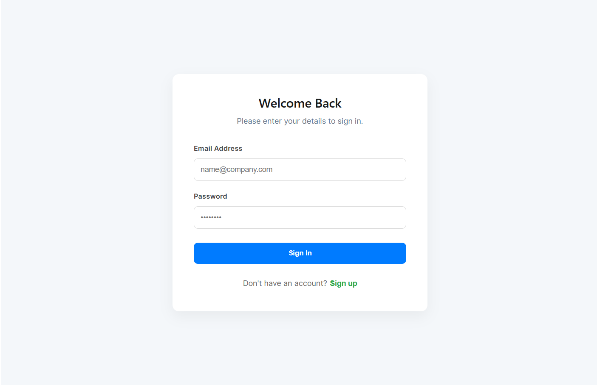
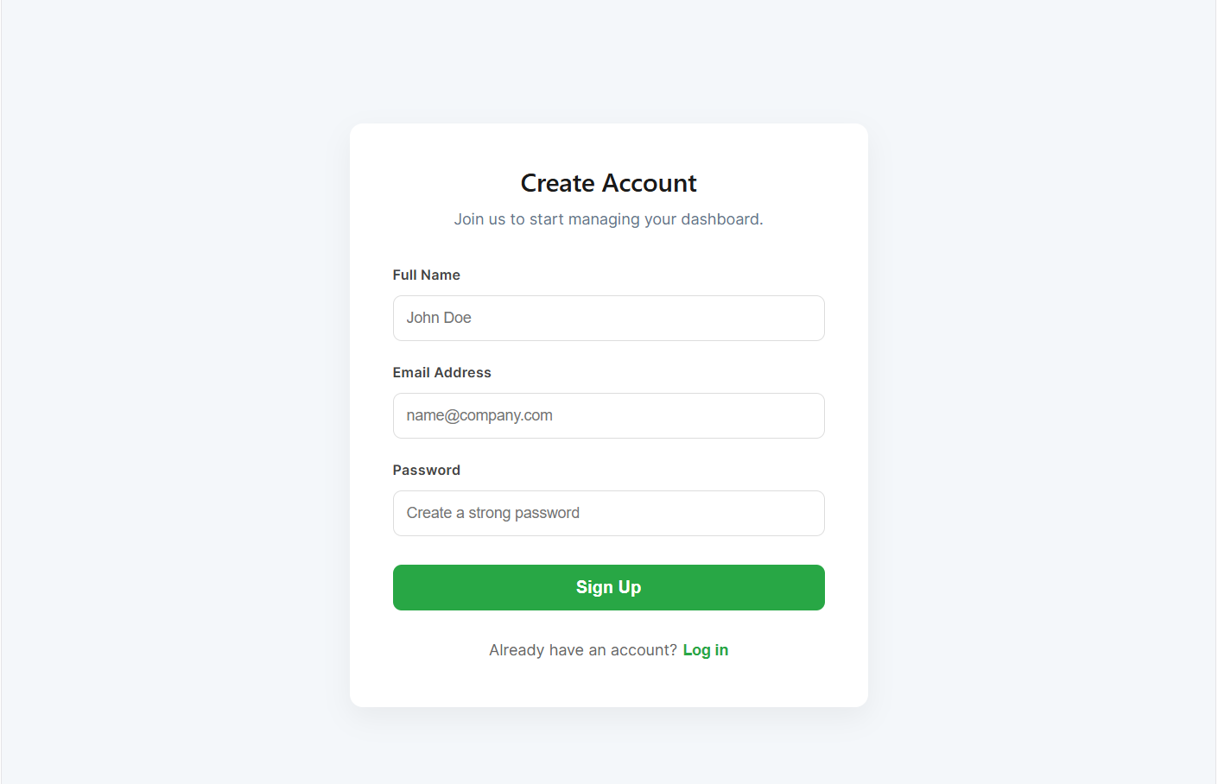

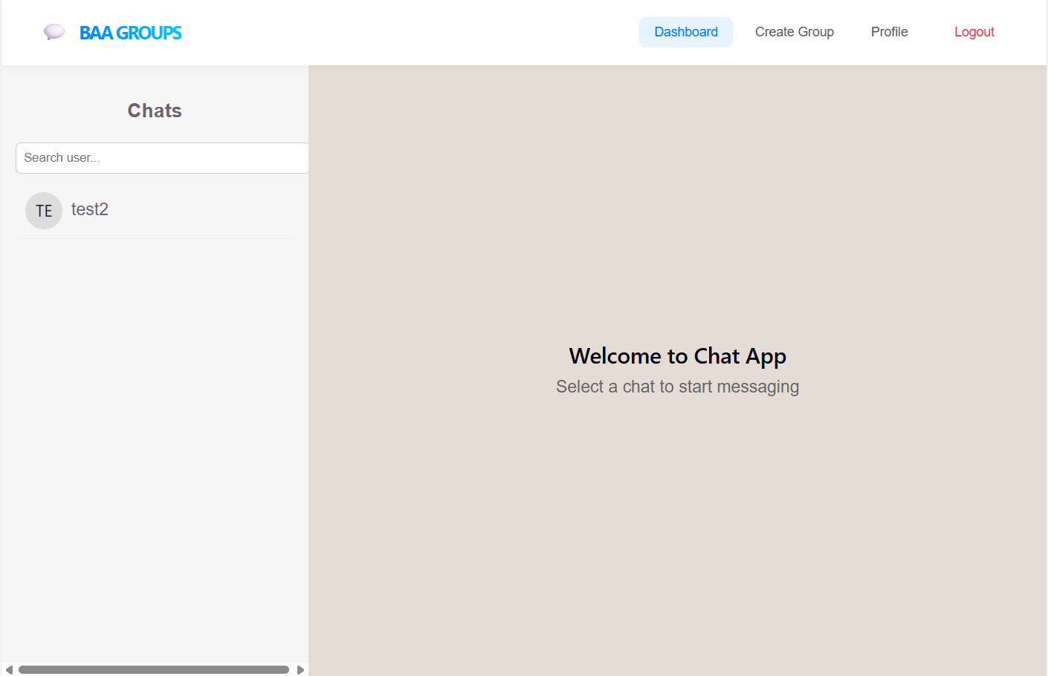
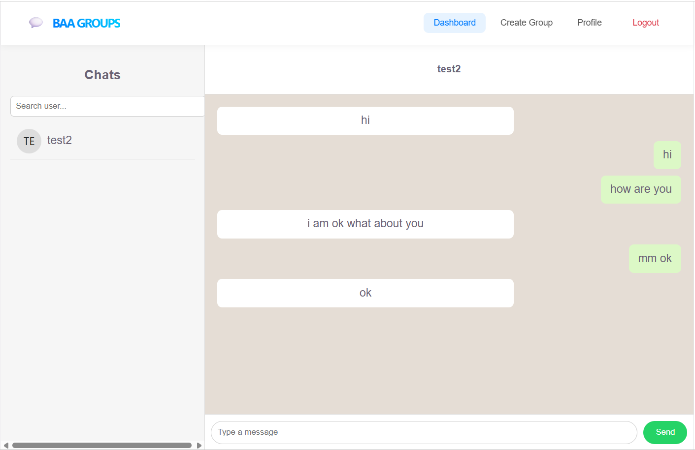
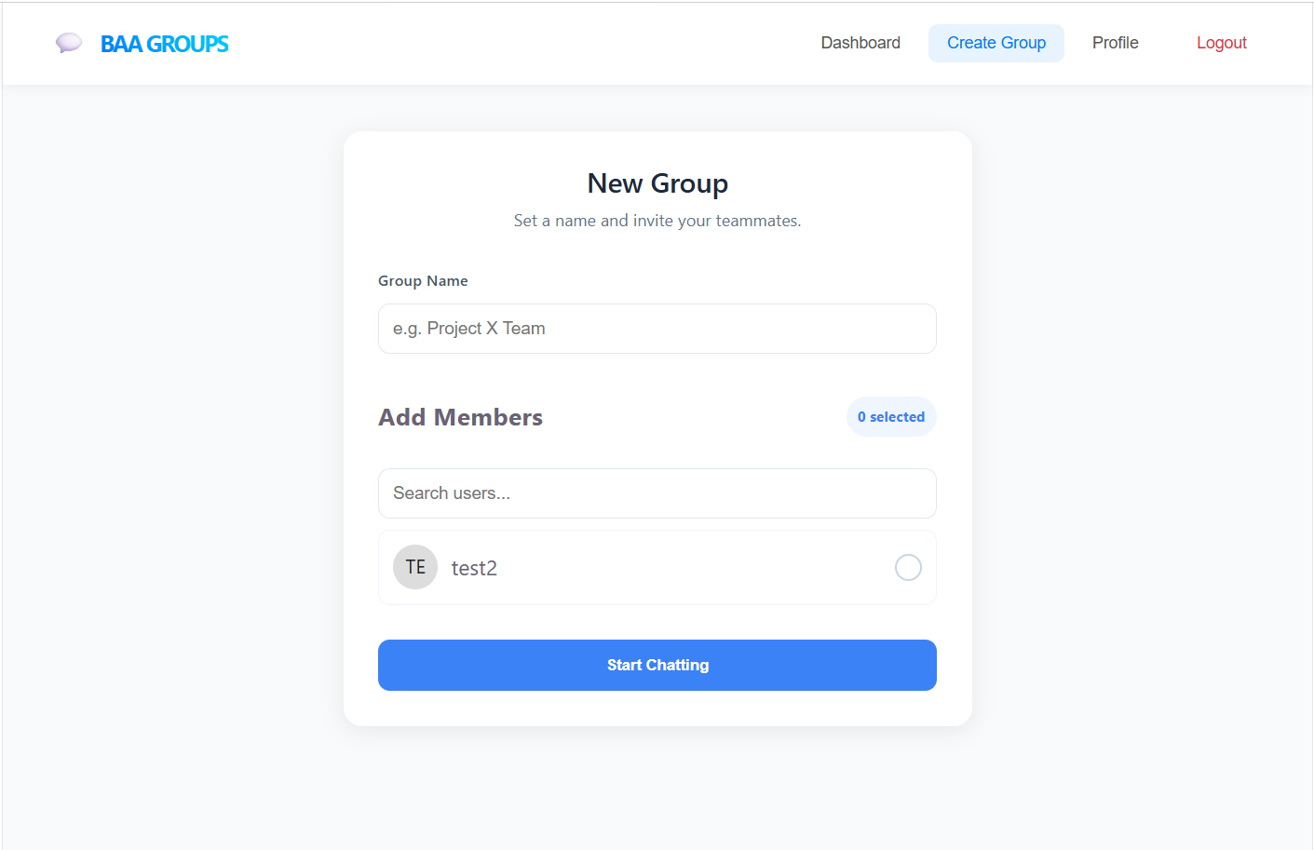
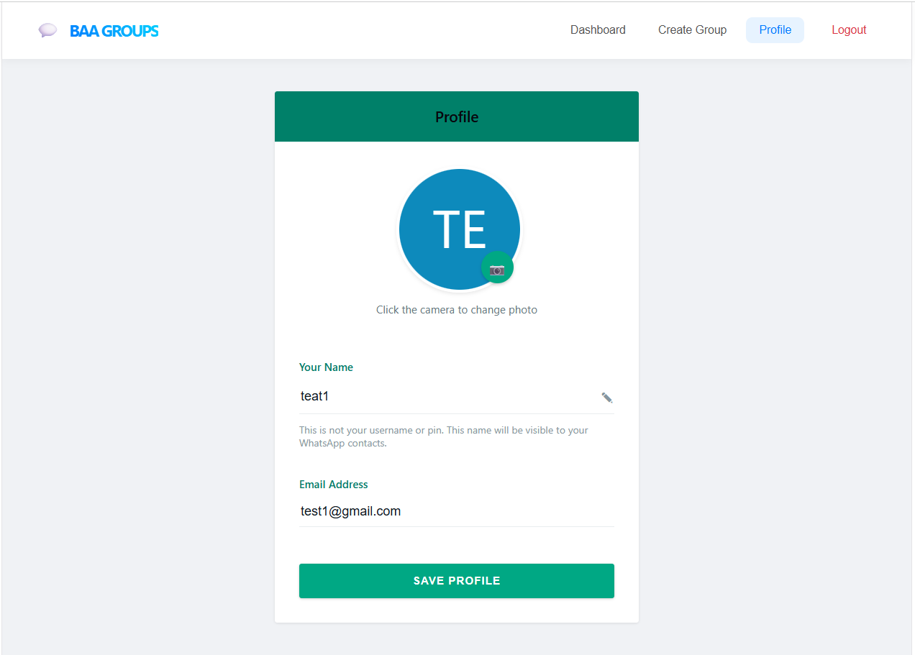

9.2 Source Code
Backend Folder Structure :
communication-backend
│
├── config
│ └── db.js
│
├── controllers
│ ├── authController.js
│ ├── chatController.js
│ └── messageController.js
│
├── middleware
│ └── authMiddleware.js
│
├── models
│ ├── User.js
│ ├── Chat.js
│ └── Message.js
│
├── routes
│ ├── authRoutes.js
│ ├── chatRoutes.js
│ └── messageRoutes.js
│
├── uploads
│
├── server.js
└── .env

Backend Source code :
communication-backend/.env:
PORT=5000
MONGO_URI=mongodb://127.0.0.1:27017/chatapp
JWT_SECRET=chatsecret
config/db.js :
const mongoose = require("mongoose")
const connectDB = async () => {
try{
await mongoose.connect(process.env.MONGO_URI)
console.log("MongoDB Connected")
}
catch(err){
console.log(err)
process.exit(1)
}
}
module.exports = connectDB

controllers/authController.js:
const User = require("../models/User")
const bcrypt = require("bcryptjs")
const jwt = require("jsonwebtoken")
exports.signup = async(req,res)=>{
try{
const {name,email,password} = req.body
const userExists = await User.findOne({email})
if(userExists)
return res.status(400).json({msg:"User exists"})
const hash = await bcrypt.hash(password,10)
const user = await User.create({
name,
email,
password:hash
})
res.json(user)
}
catch(err){
res.status(500).json(err)
}
}
exports.login = async(req,res)=>{
try{
const {email,password} = req.body
const user = await User.findOne({email})
if(!user)
return res.status(400).json({msg:"User not found"})
const match = await bcrypt.compare(password,user.password)
if(!match)
return res.status(400).json({msg:"Wrong password"})
const token = jwt.sign(
{id:user._id},
process.env.JWT_SECRET,
{expiresIn:"7d"}
)
res.json({token,user})
}
catch(err){
res.status(500).json(err)
}
}

Controllers/chatController.js :

const Chat = require("../models/Chat")
/* CREATE OR GET PRIVATE CHAT */
exports.createChat = async (req, res) => {
try {
const { userId } = req.body
if (!userId) {
return res.status(400).json({ message: "User ID required" })
}
/* CHECK IF CHAT ALREADY EXISTS */
let chat = await Chat.findOne({
isGroupChat: false,
users: { $all: [req.user.id, userId] }
})
.populate("users", "name email profilePic")
.populate("groupAdmin", "name")
/* RETURN EXISTING CHAT */
if (chat) {
return res.json(chat)
}
/* CREATE NEW CHAT */
chat = await Chat.create({
users: [req.user.id, userId]
})
/* POPULATE USER DETAILS *
chat = await Chat.findById(chat._id)
.populate("users", "name email profilePic")
res.json(chat)
} catch (err) {
console.error(err)
res.status(500).json({ message: "Server error" })
}
}
/* CREATE GROUP CHAT */
exports.createGroup = async (req, res) => {
try {
const { name, users } = req.body
if (!name || !users) {
return res.status(400).json({
message: "Group name and users required"
})
}
/* CREATE GROUP */
const group = await Chat.create({
chatName: name,
isGroupChat: true,
users: [...users, req.user.id],
groupAdmin: req.user.id
})
/* POPULATE GROUP DETAILS */
const fullGroup = await Chat.findById(group._id)
.populate("users", "name email profilePic")
.populate("groupAdmin", "name")
res.json(fullGroup)
} catch (err) {
console.error(err)
res.status(500).json({ message: "Server error" }
}
}
/* GET USER CHATS */
exports.getChats = async (req, res) => {
try {
const chats = await Chat.find({
users: req.user.id
})
.populate("users", "name email profilePic")
.populate("groupAdmin", "name")
.sort({ updatedAt: -1 })
res.json(chats)
} catch (err) {
console.error(err)
res.status(500).json({ message: "Server error" })
}
}
Controllers/messageController.js :
const Message = require("../models/Message")
const Chat = require("../models/Chat"
// SEND MESSAGE
exports.sendMessage = async (req,res)=>{
try{
const {content,chatId} = req.body
if(!content || !chatId){
return res.status(400).json({message:"Content and ChatId required"})
}
let message = await Message.create({
sender:req.user.id,
content,
chat:chatId
})
// populate sendermessage = await message.populate("sender","name email")
// update latest message in chat
await Chat.findByIdAndUpdate(chatId,{
latestMessage:message._id
})
res.json(message)
}catch(err){
console.error(err)
res.status(500).json({message:"Server error"})
}
// GET CHAT MESSAGES
exports.getMessages = async(req,res)=>{
try{
const messages = await Message.find({
chat:req.params.chatId
})
.populate("sender","name email")
.sort({createdAt:1})
res.json(messages)
}catch(err){
console.error(err)
res.status(500).json({message:"Server error"})
}
}
Middleware/authMiddleware.js :

const jwt = require("jsonwebtoken")
module.exports = function(req,res,next){
const token = req.headers.authorization
if(!token) return res.status(401).json({msg:"No token"})
try{
const decoded = jwt.verify(token,process.env.JWT_SECRET)
req.user = decoded
next()
}
catch(err){
res.status(401).json({msg:"Invalid token"})
}
}
Models/Chat.js:
const mongoose = require("mongoose")
const chatSchema = new mongoose.Schema({
chatName:{
type:String
},
isGroupChat:{
type:Boolean,
default:false
},
users:[
{
type:mongoose.Schema.Types.ObjectId,
ref:"User"
}
],
groupAdmin:{
type:mongoose.Schema.Types.ObjectId,
ref:"User"
}
},{timestamps:true})
module.exports = mongoose.model("Chat",chatSchema)
models/Message.js :
const mongoose = require("mongoose")
const messageSchema = new mongoose.Schema({
sender:{
type:mongoose.Schema.Types.ObjectId,
ref:"User"
},
content:{
type:String
},
chat:{
type:mongoose.Schema.Types.ObjectId,
ref:"Chat"
},
file:{
type:String
}
},{timestamps:true})
module.exports = mongoose.model("Message",messageSchema)

models/User.js :
const mongoose = require("mongoose")
const userSchema = new mongoose.Schema(
name:{
type:String,
required:true
},
email:{
type:String,
required:true,
unique:true
},
password:{
type:String,
required:true
},
profilePic:{
type:String,
default:""
},
online:{
type:Boolean,
default:false
}
},{timestamps:true})
module.exports = mongoose.model("User",userSchema)
routes/authRoutes.js:
const router = require("express").Router()
const {signup,login} = require("../controllers/authController")
router.post("/signup",signup)
router.post("/login",login)
module.exports = router
routes/chatRoutes.js:
const router = require("express").Router()
const auth = require("../middleware/authMiddleware")
const {
createChat,
createGroup,
getChats
} = require("../controllers/chatController")
// create private chat
router.post("/create", auth, createChat)
// create group chat
router.post("/group", auth, createGroup)
// get all chats
router.get("/", auth, getChats)
module.exports = router

routes/messageRoutes.js:
const router = require("express").Router()
const auth = require("../middleware/authMiddleware")
const {sendMessage,getMessages} = require("../controllers/messageController")
router.post("/",auth,sendMessage)
router.get("/:chatId",auth,getMessages)
module.exports = router
routes/userRoutes.js:
const router = require("express").Router()
const auth = require("../middleware/authMiddleware")
const User = require("../models/User")
const multer = require("multer")
/* FILE UPLOAD CONFIG */
const storage = multer.diskStorage({
destination:(req,file,cb)=>{
cb(null,"uploads/")
},
filename:(req,file,cb)=>{
cb(null,Date.now()+"-"+file.originalname)
}
})
const upload = multer({storage})
/* SEARCH USERS */
router.get("/search", auth, async (req,res)=>{

try{
const search = req.query.search || ""
const users = await User.find({
name:{ $regex:search, $options:"i" },
_id:{ $ne:req.user.id }
}).select("-password")
res.json(users)
}catch(err){
console.error(err)
res.status(500).json({message:"Server error"})
}
})
/* GET PROFILE */
router.get("/profile", auth, async (req,res)=>{
try{
const user = await User.findById(req.user.id)
.select("-password")
res.json(user)
}catch(err){
console.error(err)
res.status(500).json({message:"Server error"})
}
})
/* UPDATE PROFILE */

router.put("/profile", auth, upload.single("profilePic"), async (req,res)=>{
try{
const {name,email} = req.body
let updateData = {name,email}
if(req.file){
updateData.profilePic = req.file.filename
}
const user = await User.findByIdAndUpdate(
req.user.id,
updateData,
{new:true}
).select("-password")
res.json(user)
}catch(err){
console.error(err)
res.status(500).json({message:"Server error"})
}
})
module.exports = router

communication-backend/server.js:
require("dotenv").config(
const express = require("express")
const cors = require("cors")
const http = require("http")
const {Server} = require("socket.io")
const connectDB = require("./config/db")
const authRoutes = require("./routes/authRoutes")
const chatRoutes = require("./routes/chatRoutes")
const messageRoutes = require("./routes/messageRoutes")
const userRoutes = require("./routes/userRoutes")
const dns = require("node:dns/promises")
dns.setServers(["8.8.8.8","8.8.4.4"])
connectDB()
const app = express()
app.use(cors())
app.use(express.json())
/* SERVE PROFILE IMAGES */
app.use("/uploads", express.static("uploads"))
/* ROUTES */
app.use("/api/auth",authRoutes)
app.use("/api/chat",chatRoutes)
app.use("/api/message",messageRoutes)
app.use("/api/users",userRoutes)
const server = http.createServer(app)
const io = new Server(server,{
cors:{
origin:"*"
}})
io.on("connection",(socket)=>{
console.log("User connected:",socket.id)
socket.on("joinRoom",(room)=>{
socket.join(room)
})
socket.on("sendMessage",(data)=>{
io.to(data.room).emit("receiveMessage",data)
})
socket.on("disconnect",()=>{
console.log("User disconnected")
})
})
server.listen(process.env.PORT || 5000,()=>{
console.log("Server running on port",process.env.PORT || 5000)
})

